**Nitya patil_wipro_training_batch(3)_Satinnder**

**Task – 1[day -1- 14/6/2024]**

Computer architecture – blue print of the computer

* RAM is primary memory (it takes the load)(volatile)
* Hard disk is secondary memory (it save the document)
* Cache is flash memory (It store depends up on the instruction we give).
* ROM read only memory (where we installed the operating system)(non volatile)

**1.WHAT IS THE DIFFERENCE BETWEEN SINGLE, DUAL, QUAD CORE ?**







**2.WHAT IS THE DIFFERENCE BETWEEN THE CORE i5 and i7 ?**

|  |  |  |
| --- | --- | --- |
| **Intel Core i3** | **Intel Core i5** | **Intel Core i7** |
| Intel Core i3 is an entry-level processor design for low-end applications. | Intel Core i5 is a mid-range processor developed for everyday use computer systems. | Intel Core i7 is a high-end processor designed for applications that need high processing power. |
| Core i3 processor is a dual core processor, i.e. it has two physical cores. | Core i5 is available in quad-core (2 cores) and quad core (4 cores). | Core i7 is available in quad core (4 cores), six cores, and eight-cores. |
| Core i3 has a cache of size either 3 MB or 4 MB. | Core i5 has a cache of size ranging between 3 MB and 8 MB. | Core i7 has a cache of size ranging between 4 MB and 8 MB. |
| The clock speed of Core i3 processor is ranging between 1.30 GHz and 3.50 GHz. | The clock speed of Core i5 processor is ranging between 1.90 GHz and 3.80 GHz. | The clock speed of Core i7 processor is ranging between 2.6 GHz and 3.7 GHz. |
| Core i3 processor supports 4 threads. | Core i5 processor also supports 4 threads. | Core i7 processor supports 8 threads. |
| Core i3 processor does not support turbo boost feature. | Core i5 supports turbo boost. | Core i7 processor also supports turbo boost. |
| Core i3 processor does not support virtualization technology. | Core i5 processor supports virtualization technology. | Core i7 processor also supports virtualization technology. |
| Core i3 processor does not support Intel vPro technology. | Core i5 processor does not support Intel vPro technology. | Core i7 processor supports Intel vPro technology. |
| Core i3 processor is cheapest among the three. | Core i5 is mid-range processor. | Core i7 is expensive. |
| Core i3 processor is suitable to use for entry level tasks such as word processing, browsing, documentation, watching videos, etc. | Core i5 processor is suitable for basic work like web browsing, word processing, spreadsheets, basic graphics designing, etc. | Core i7 processor is suitable for high end applications, such as gaming, graphics designing, video editing, simulation, etc. |

**Day 2[17/6/2024]**

**Task: Check the ip address**

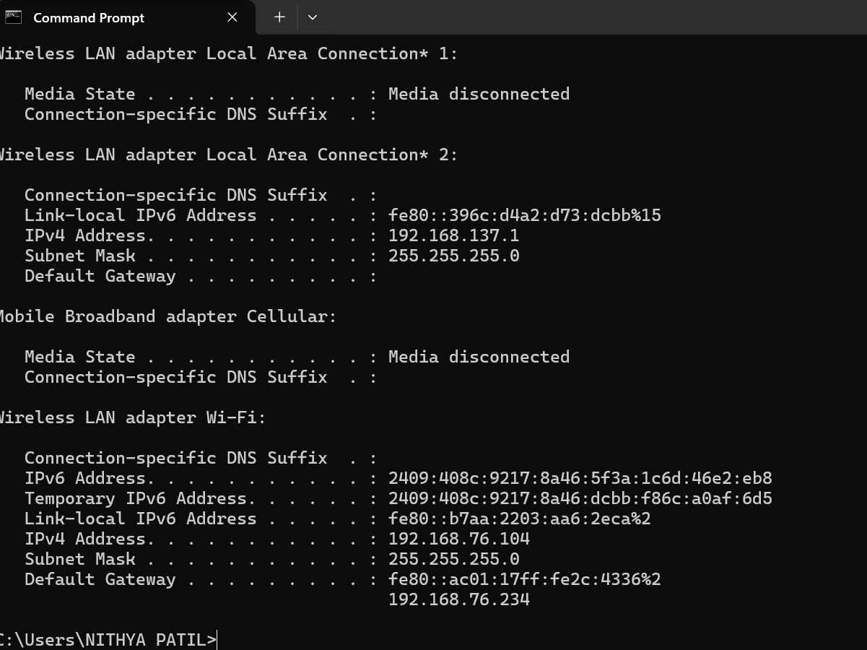

**Task : write the ip address**

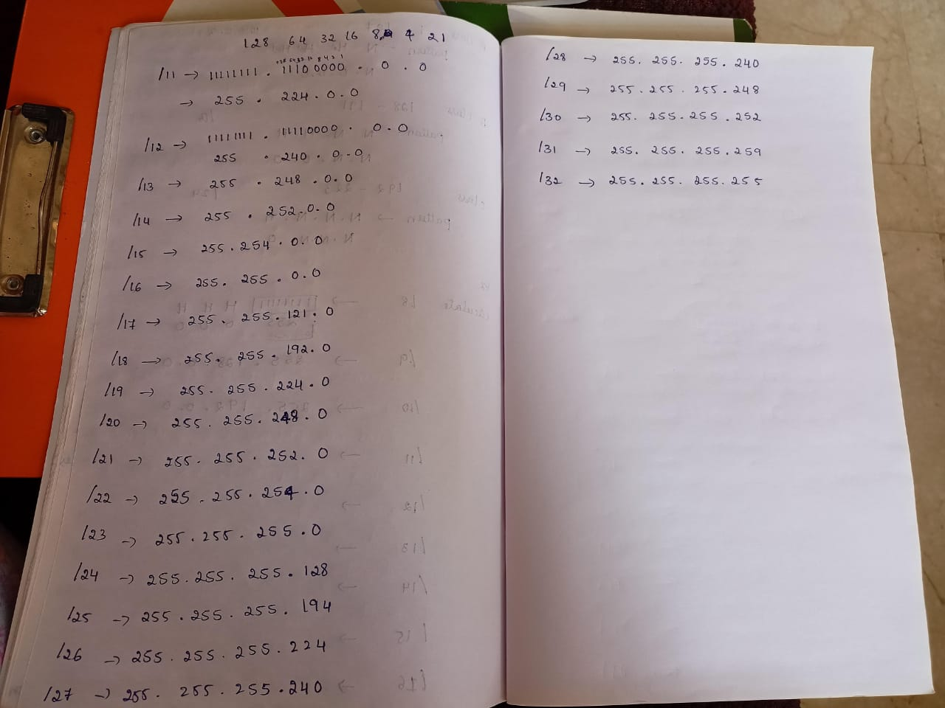

**Tasks**

**Binary to Decimal conversion**

10010010 = 146

01110111 = 119

11111111 = 255

11110110 = 246

00010011 = 19

10000001 = 129

00110001 = 49

01111000 = 120

11110000 = 240

00111011 = 59

00000111 = 7

**Decimal to binary conversion**

238 = 11101110

34 = 00100010

123 = 1111011

50 = 00110010

255 = 11111111

200 =11001000

10 = 00001010

138 = 10001010

1 = 00000001

13 = 00001101

250 = 11111010

107 = 01101011

224 = 11100000

114 = 01110010

192 = 11000000

**Address class identification**

10.250.1.1 = A

150.10.15.0 = B

192.14.2.0 = C

148.17.9.1 = B

193.42.1.1 = C

126.8.156.0 = A

220.200.23.1 = C

230.230.45.58 = D

177.100.18.4 = C

119.18.45.0 = B

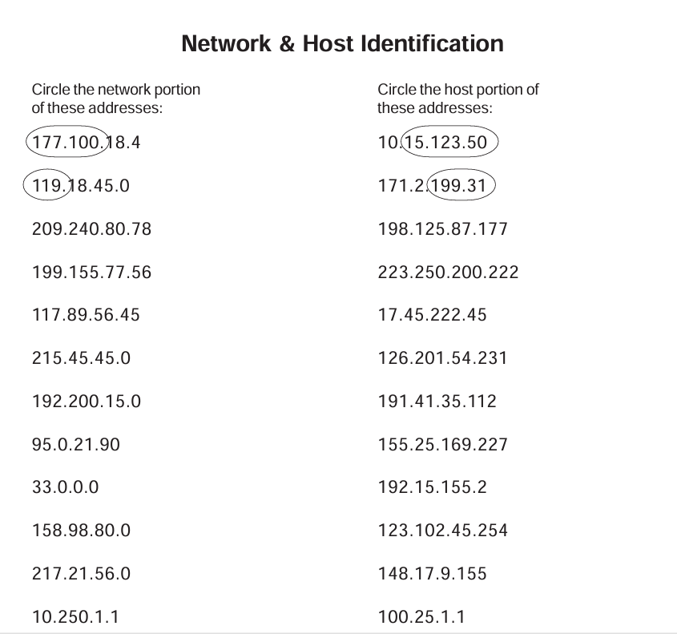

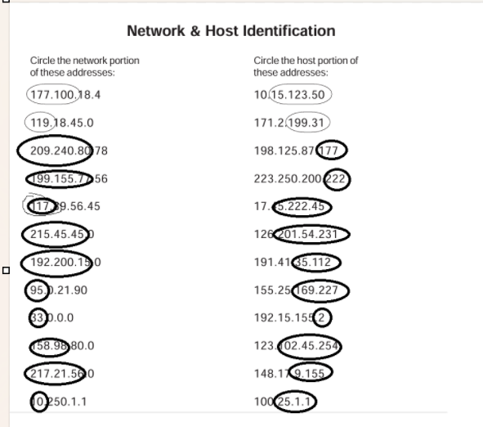

**Network address**

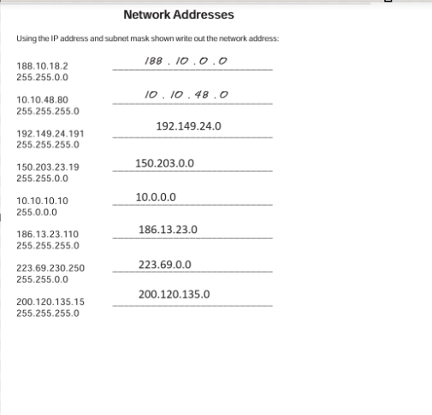

**Host addresses**

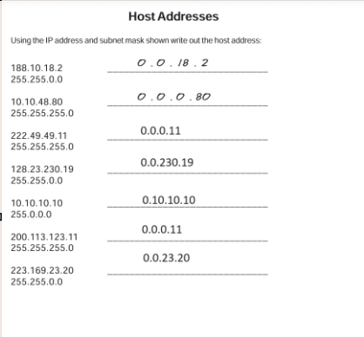

**Default address**

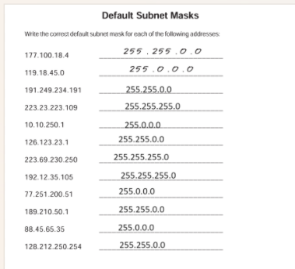

**DAY 3 [18/6/2024]**

**Task 1**

1. Connect two routers
2. Connect Router with a Switch
3. Connect Router with PC
4. Connect PC with a switch

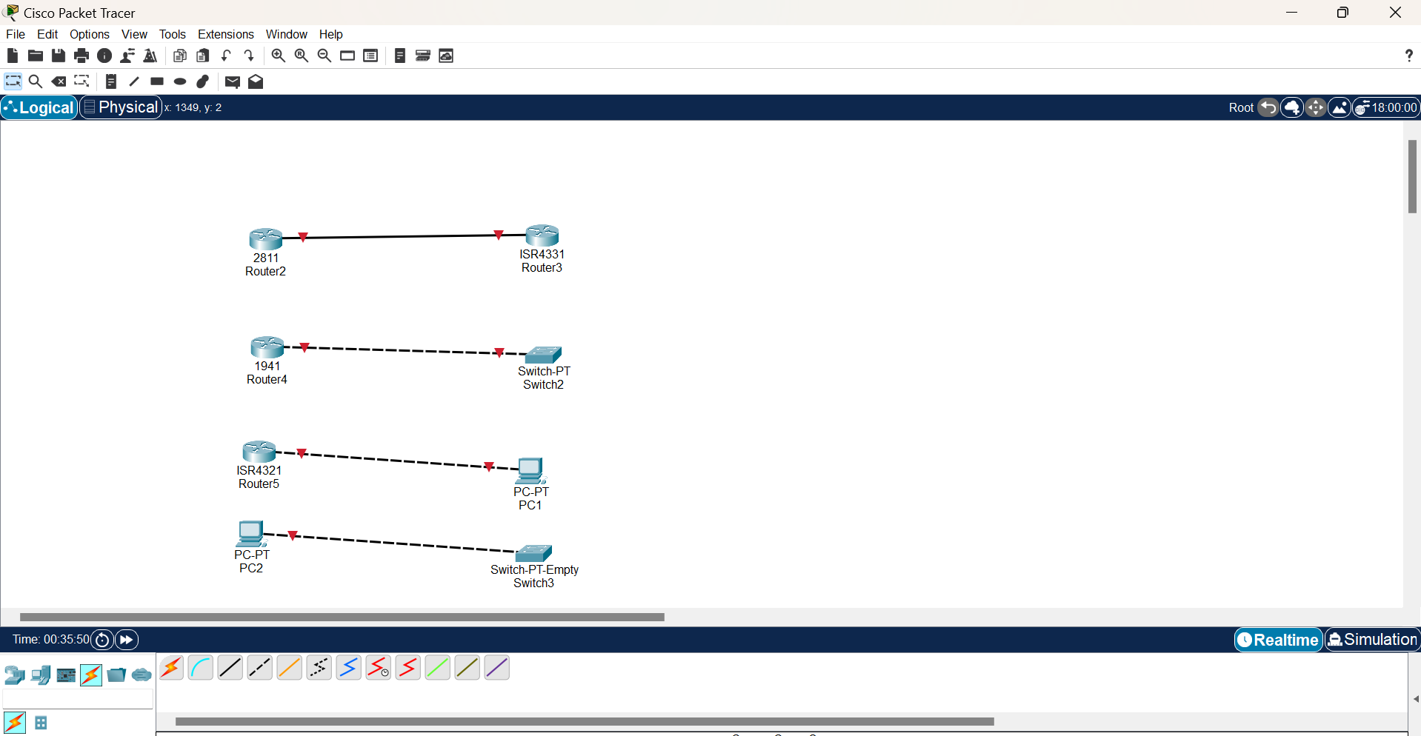

**Task 2**

**First Connection router 2811 to pc**

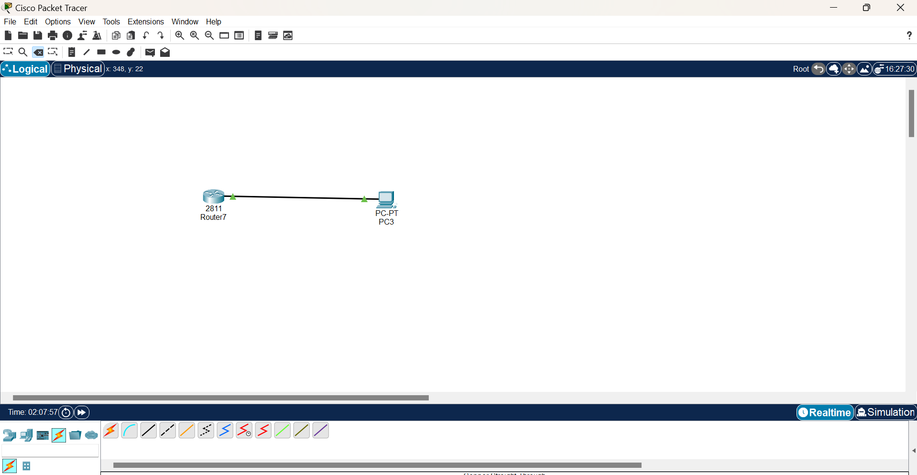

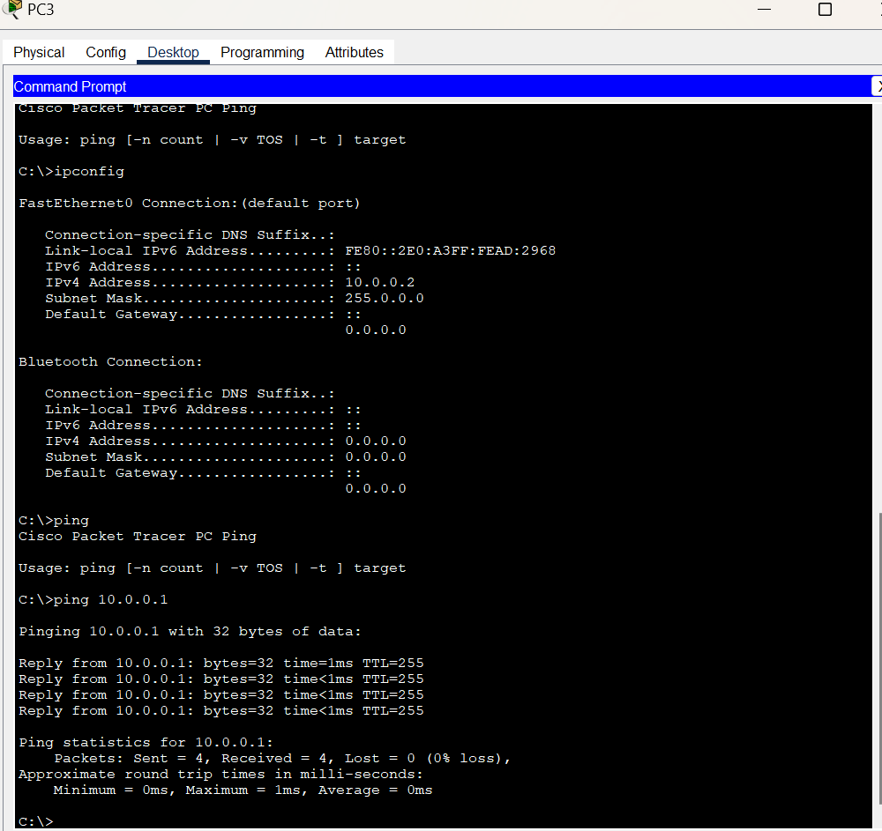

**Task 3**

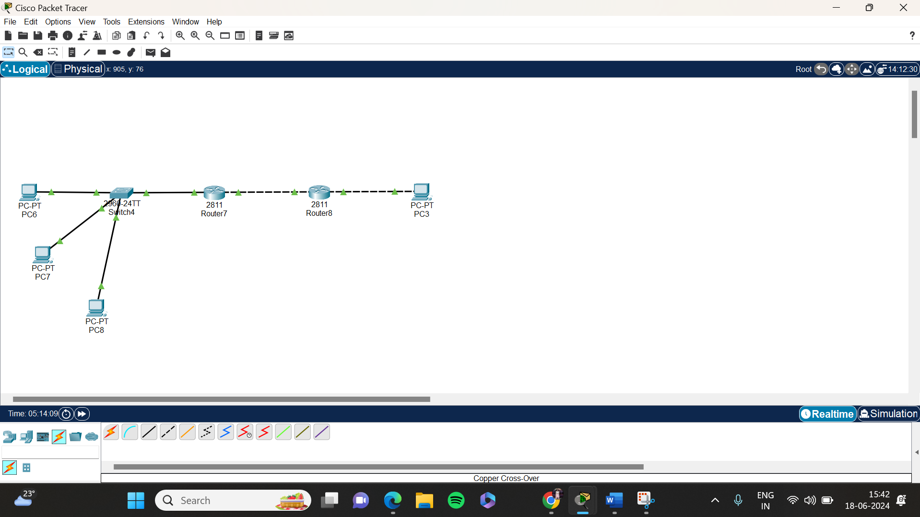

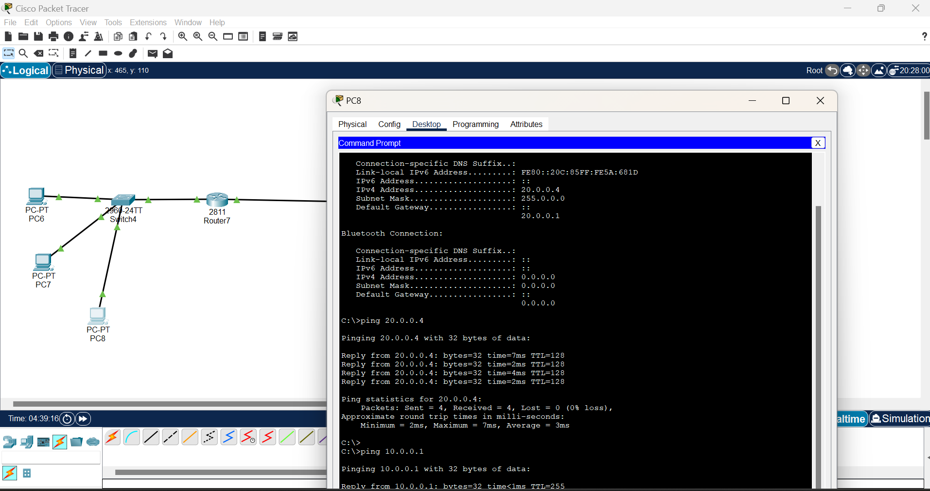

**Day 4[19/6/2024]**

**Task 1**

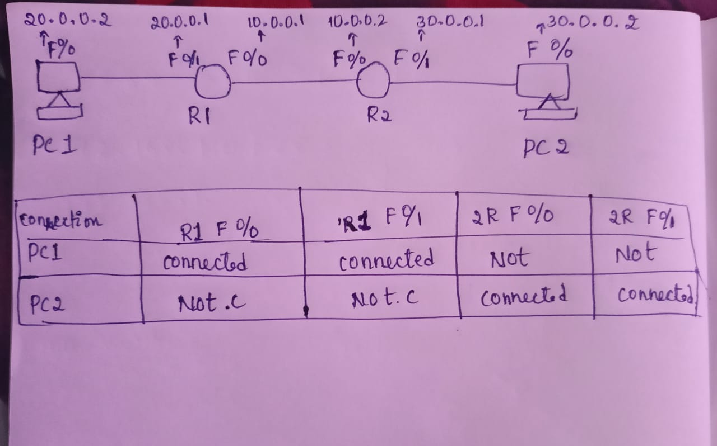

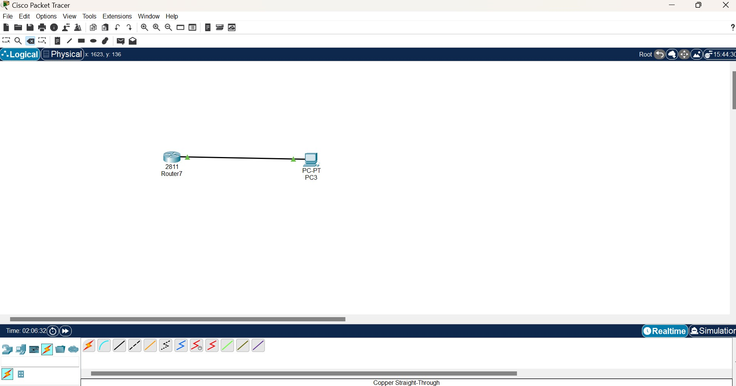

**Task 2**

**To connect all IP address ping it (connect router to PC)**

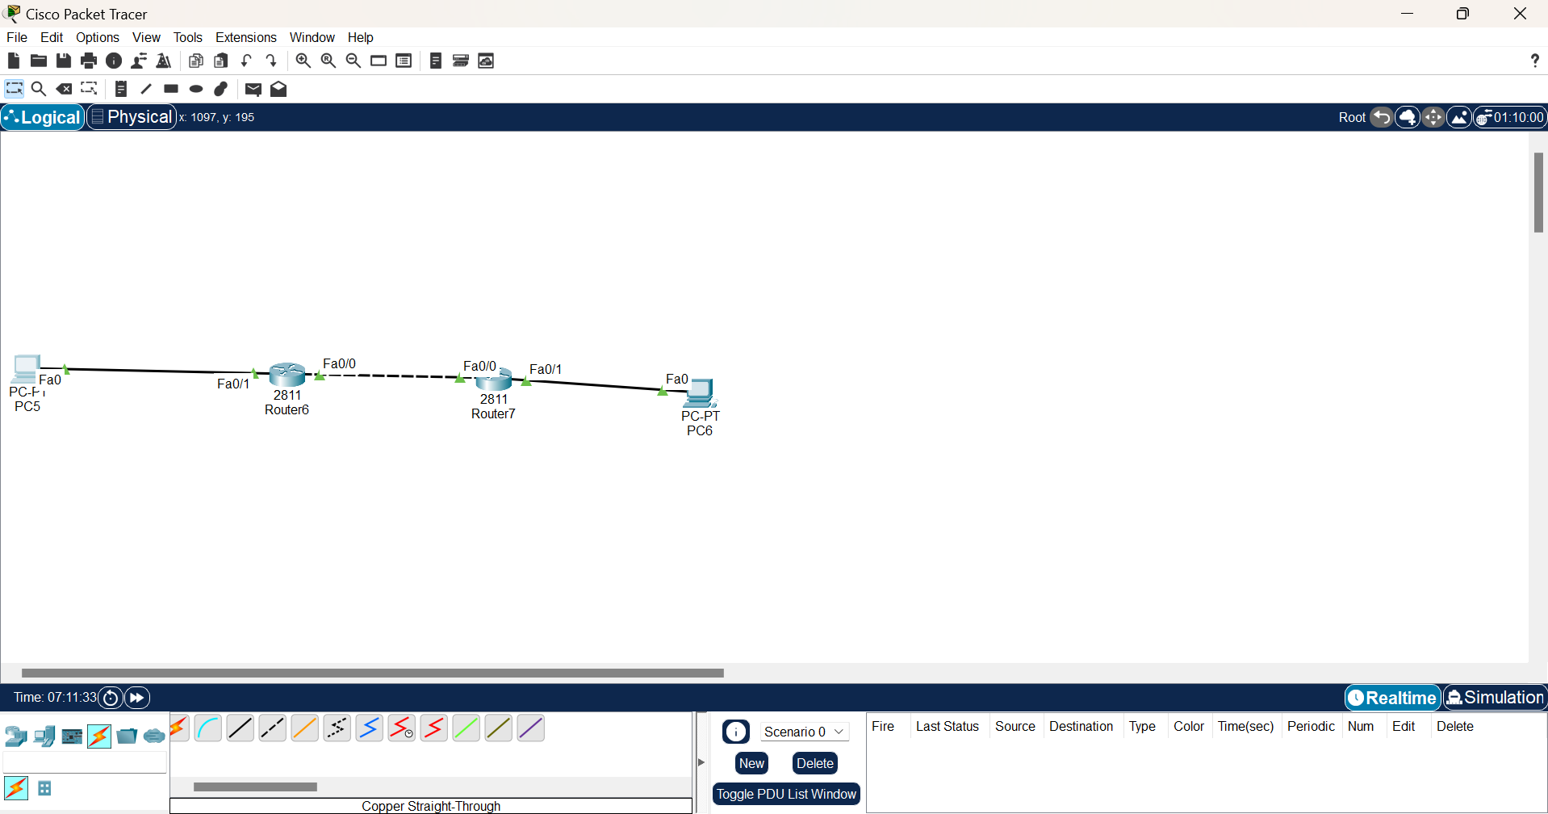

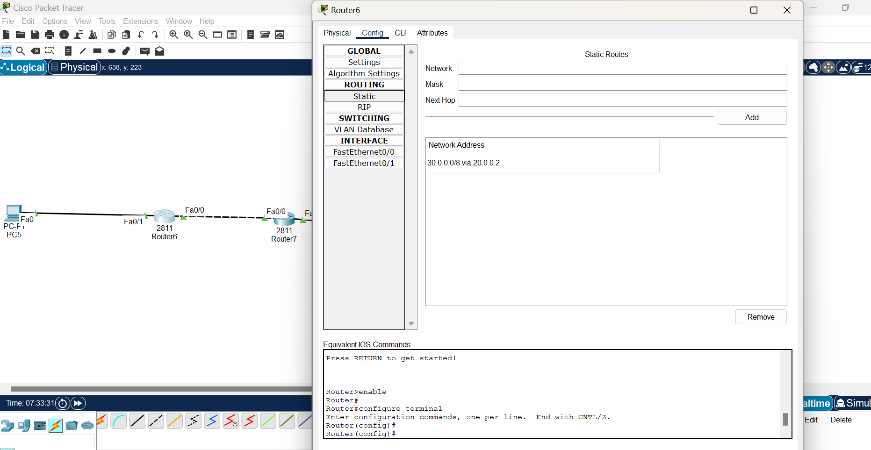

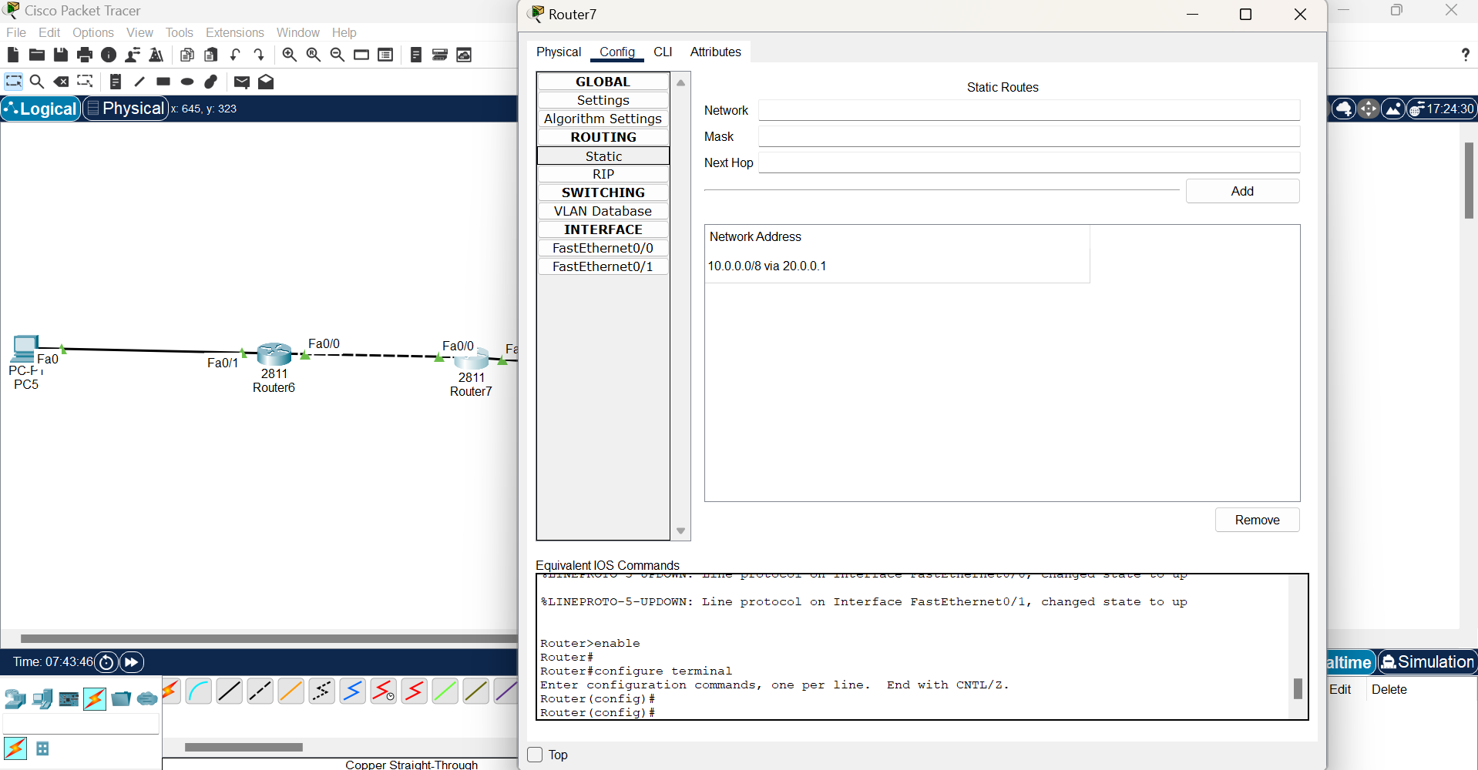

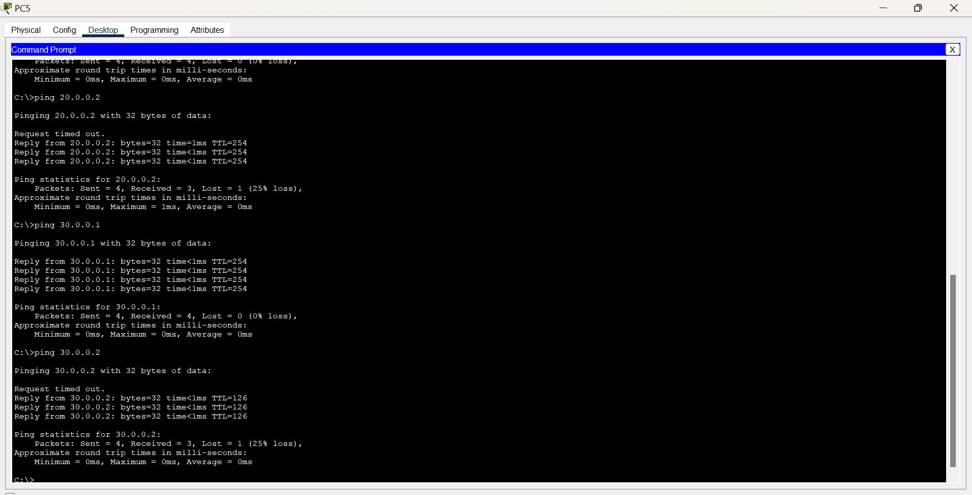

**Day 5[20/06/2024]**

**Task 1 : Information about OSI models**

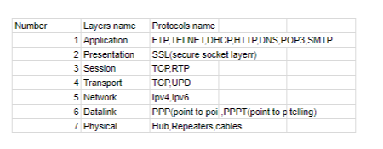

**Difference between OSI vs TCP/IP**

Data communication is a process or act in which we can send or receive data. For data communication two models are available. We will discuss these two models in this article and also see the differences between these two articles.

* OSI Model
* TCP/IP Model

**OSI Model**

[OSI](https://www.geeksforgeeks.org/layers-of-osi-model/)stands for Open Systems Interconnection. It has 7 layers Physical layer, Data Link layer, Network layer, Transport layer, Session layer, Presentation layer, and Application layer. Each layer performs its task independently. It was developed in 1984 by the International Organization for Standardization (ISO).

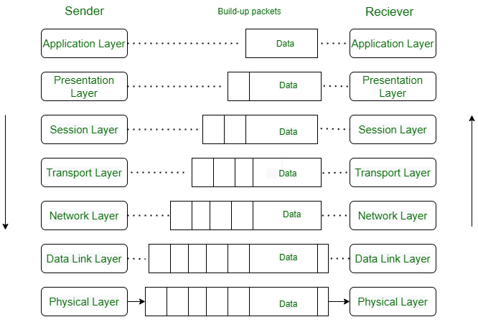

### **Advantages**

* Both connection-oriented services and connectionless services are supported.
* It is quite flexible.
* All the layers work independently.

### **Disadvantages**

* Setting up a model is a challenging task.
* Sometimes, it becomes difficult to fit a new protocol into this model.
* It is only used as a reference model.

## TCP/IP Model

[TCP/IP](https://www.geeksforgeeks.org/tcp-ip-model/) stands for Transmission Control Protocol/Internet Protocol. It has 4 layers named as Physical layer, Network layer, Transport layer, and Application layer.  It also can be used as a communications protocol in a private computer network. It was designed by Vint Cerf and Bob Kahn in the 1970s.

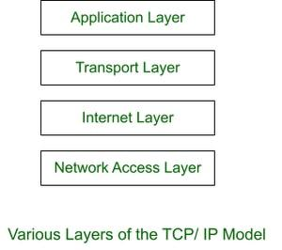

### **Advantages**

* Many Routing protocols are supported.
* It is highly scalable and uses a client-server architecture.
* It is lightweight.

### **Disadvantages**

* Little difficult to set up.
* Delivery of packets is not guaranteed by the transport layer.
* Vulnerable to a synchronization attack.

## Similarities between OSI Model and TCP/IP Model

## 

OSI and TCP/IP both are logical models. One of the main similarities between the OSI and TCP/IP models is that they both describe how information is transmitted between two devices across a network. Both models define a set of layers. Each layer performs a specific set of functions to enable the transmission of data.

Another similarity between the two models is that they both use the concept of encapsulation, in which data is packaged into a series of headers and trailers that contain information about the data being transmitted and how it should be handled by the network

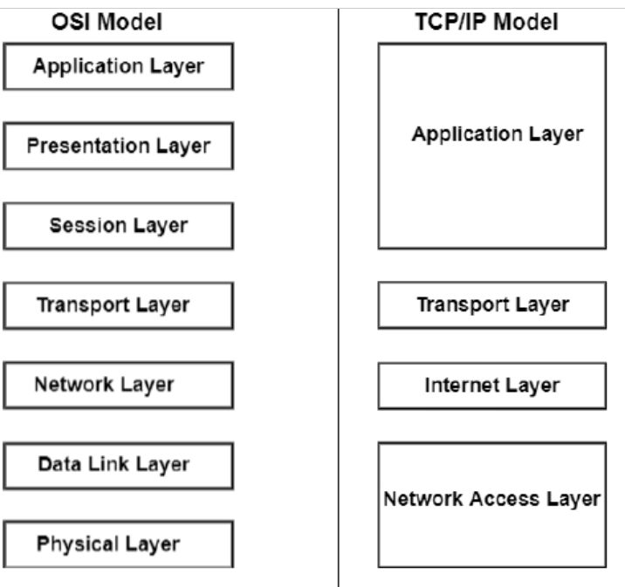

.

**Differences between OSI Model and TCP/IP Model**

| **Parameters** | **OSI Model** | **TCP/IP Model** |
| --- | --- | --- |
| **Full Form** | OSI stands for Open Systems Interconnection. | TCP/IP stands for Transmission Control Protocol/Internet Protocol. |
| **Layers** | It has 7 layers. | It has 4 layers. |
| **Usage** | It is low in usage. | It is mostly used. |
| **Approach** | It is vertically approached. | It is horizontally approached. |
| **Delivery** | Delivery of the package is guaranteed in OSI Model. | Delivery of the package is not guaranteed in TCP/IP Model. |
| **Replacement** | Replacement of tools and changes can easily be done in this model. | Replacing the tools is not easy as it is in OSI Model. |
| **Reliability** | It is less reliable than TCP/IP Model. | It is more reliable than OSI Model. |

**Layer services and port number:**

**1.Application layer**

Protocol:

1.HTTP – 80, 8080

2.HTTPS – 443

3.FTP – 20,21

4.TELNET – 23

5.DHCP – 68(client), 67(server)

6.DNS - 53

7.SMPT – 161

8.TFTP - 69

1. **Hypertext Transfer Protocol (HTTP)**:
   * Port: 80 (TCP)
2. **Hypertext Transfer Protocol Secure (HTTPS)**:
   * Port: 443 (TCP)
3. **File Transfer Protocol (FTP)**:
   * Port: 21 (TCP for control), 20 (TCP for data transfer)
4. **Simple Mail Transfer Protocol (SMTP)**:
   * Port: 25 (TCP)
5. **Post Office Protocol version 3 (POP3)**:
   * Port: 110 (TCP)
6. **Internet Message Access Protocol (IMAP)**:
   * Port: 143 (TCP)
7. **Domain Name System (DNS)**:
   * Port: 53 (TCP/UDP)
8. **Telnet**:
   * Port: 23 (TCP)
9. **Secure Shell (SSH)**:
   * Port: 22 (TCP)
10. **Simple Network Management Protocol (SNMP)**:

* Port: 161 (UDP for general queries), 162 (UDP for trap messages)

1. **Network Time Protocol (NTP)**:

* Port: 123 (UDP)

1. **Lightweight Directory Access Protocol (LDAP)**:

* Port: 389 (TCP/UDP), 636 (TCP for LDAP over SSL/TLS)

1. **Hypertext Transfer Protocol over TLS/SSL (HTTPS)**:

* Port: 443 (TCP)

1. **Trivial File Transfer Protocol (TFTP)**:

* Port: 69 (UDP)

1. **Internet Relay Chat (IRC)**:

* Port: 194 (TCP)

1. **Simple Object Access Protocol (SOAP) over HTTP**:

* Port: 80 (TCP)

1. **Real-Time Streaming Protocol (RTSP)**:

* Port: 554 (TCP/UDP)

1. **Microsoft SQL Server**:

* Port: 1433 (TCP)

1. **MySQL Database Service**:

* Port: 3306 (TCP)

1. **Remote Desktop Protocol (RDP)**:

* Port: 3389 (TCP)

1. **Dynamic Host Configuration Protocol (DHCP)**:

* Port: 67 (UDP server), 68 (UDP client)

1. **Bootstrap Protocol (BOOTP)**:

* Port: 67 (UDP server), 68 (UDP client)

1. **Simple Service Discovery Protocol (SSDP)**:

* Port: 1900 (UDP)

1. **Internet Printing Protocol (IPP)**:

* Port: 631 (TCP/UDP)

**2.Presentation layer**

Protocol:

1.SSL-443

2.HTTP-80

3.FTP-20,21

**3.Session layer**

Protocol:

**1.Session Initiation Protocol (SIP)**:

* Port: 5060 (TCP/UDP), 5061 (TCP for SIP over TLS)

**2.NetBIOS**:

* Port: 137 (UDP for name service), 138 (UDP for datagram service), 139 (TCP for session service)

**3.** **Remote Procedure Call (RPC)**:

* Port: 135 (TCP/UDP)

**4.** **AppleTalk Session Protocol (ASP)**:

* Port: Generally used within the AppleTalk suite and does not have a direct mapping to a specific port number.

**5.** **ISO Transport Service Access Point (TSAP)**:

* Port: Typically used in conjunction with other protocols and does not have a standard port number.

**4.Transport layer:**

Protocols:

1. **Transmission Control Protocol (TCP)**:
   * Port: TCP itself doesn't have a specific port number. Instead, it uses port numbers to identify specific services on a host. Examples include HTTP (port 80), HTTPS (port 443), FTP (port 21), and SSH (port 22).
2. **User Datagram Protocol (UDP)**:
   * Port: Similar to TCP, UDP doesn't have a specific port number. It uses port numbers to identify specific services on a host. Examples include DNS (port 53), TFTP (port 69), and NTP (port 123).
3. **Stream Control Transmission Protocol (SCTP)**:
   * Port: SCTP itself doesn't have a specific port number, but it is used for applications like telephony signaling (e.g., SS7) and may share ports with similar services.
4. **Datagram Congestion Control Protocol (DCCP)**:
   * Port: DCCP itself doesn't have a specific port number. It is used for congestion-controlled, unreliable datagram flows and may share ports with similar services.

Here are some common services and their well-known port numbers, primarily over TCP and UDP:

### TCP Ports:

1. **HTTP**: 80
2. **HTTPS**: 443
3. **FTP**: 21 (Control), 20 (Data)
4. **SMTP**: 25
5. **POP3**: 110
6. **IMAP**: 143
7. **SSH**: 22
8. **Telnet**: 23
9. **MySQL**: 3306
10. **Microsoft SQL Server**: 1433
11. **RDP**: 3389
12. **LDAP**: 389
13. **LDAPS**: 636
14. **SMTP over SSL/TLS (SMTPS)**: 465
15. **IMAP over SSL/TLS (IMAPS)**: 993
16. **POP3 over SSL/TLS (POP3S)**: 995

### UDP Ports:

1. **DNS**: 53
2. **DHCP**: 67 (Server), 68 (Client)
3. **TFTP**: 69
4. **NTP**: 123
5. **SNMP**: 161 (Queries), 162 (Traps)
6. **RADIUS**: 1812 (Authentication), 1813 (Accounting)
7. **Syslog**: 514
8. **SIP**: 5060, 5061 (TLS)

### Both TCP and UDP Ports:

1. **DNS**: 53
2. **LDAP**: 389
3. **SMB/CIFS**: 445
4. **Kerberos**: 88

**5**.**Network layer:**

Protocols:

• **Internet Protocol (IP)**:

* **IPv4**: Provides packet delivery for IPv4 addresses.
* **IPv6**: Provides packet delivery for IPv6 addresses.
* Port: N/A (IP itself does not use port numbers).

• **Internet Control Message Protocol (ICMP)**:

* Function: Used for error messages, diagnostics, and network status queries (e.g., ping).
* Port: N/A (ICMP does not use port numbers).

• **Internet Group Management Protocol (IGMP)**:

* Function: Manages multicast group memberships for IPv4 networks.
* Port: N/A (IGMP does not use port numbers).

• **Routing Information Protocol (RIP)**:

* Function: A distance-vector routing protocol used in local and wide area networks.
* Port: 520 (UDP).

• **Open Shortest Path First (OSPF)**:

* Function: A link-state routing protocol used within an autonomous system.
* Port: 89 (OSPF packets are directly encapsulated in IP datagrams, not using TCP/UDP ports).

• **Border Gateway Protocol (BGP)**:

* Function: A path-vector routing protocol used to exchange routing information between autonomous systems.
* Port: 179 (TCP).

• **Intermediate System to Intermediate System (IS-IS)**:

* Function: A link-state routing protocol used to move information efficiently within a computer network.
* Port: N/A (IS-IS packets are directly encapsulated in Ethernet frames, not using TCP/UDP ports).

• **Address Resolution Protocol (ARP)**:

* Function: Resolves IP addresses to MAC (Media Access Control) addresses.
* Port: N/A (ARP operates directly on top of the link layer, not using TCP/UDP ports).

• **Neighbor Discovery Protocol (NDP)** (for IPv6):

* Function: Provides address autoconfiguration and resolution of IP addresses to MAC addresses.
* Port: N/A (NDP does not use port numbers).

• **Enhanced Interior Gateway Routing Protocol (EIGRP)**:

* Function: An advanced distance-vector routing protocol used on a computer network for automating routing decisions and configuration.
* Port: N/A (EIGRP packets are directly encapsulated in IP datagrams, not using TCP/UDP ports).

**6.Datalink layer:**

**Protocols:**

The data link layer (Layer 2 of the OSI model) is responsible for node-to-node data transfer, error detection, and handling of physical addressing (MAC addresses). Protocols at this layer are primarily concerned with the local link between devices and do not use port numbers, which are a feature of higher layers. Here are some common data link layer protocols:

1. **Ethernet**:
   * Function: The most widely used LAN technology that specifies cabling and signaling at the physical layer and packet formats at the data link layer.
   * Port: N/A (Ethernet does not use port numbers).
2. **Point-to-Point Protocol (PPP)**:
   * Function: Provides a standard method for transporting multi-protocol datagrams over point-to-point links.
   * Port: N/A (PPP does not use port numbers).
3. **High-Level Data Link Control (HDLC)**:
   * Function: A bit-oriented protocol for communication over point-to-point and multipoint links.
   * Port: N/A (HDLC does not use port numbers).
4. **Frame Relay**:
   * Function: A high-performance WAN protocol that operates at the data link layer for packet-switched networks.
   * Port: N/A (Frame Relay does not use port numbers).
5. **Asynchronous Transfer Mode (ATM)**:
   * Function: A network technology based on transferring data in cells or packets of a fixed size.
   * Port: N/A (ATM does not use port numbers).
6. **Fiber Distributed Data Interface (FDDI)**:
   * Function: A standard for data transmission in a local area network that can extend in range up to 200 kilometers.
   * Port: N/A (FDDI does not use port numbers).
7. **Logical Link Control (LLC)**:
   * Function: A sublayer of the data link layer that manages communications between devices over a single link of a network.
   * Port: N/A (LLC does not use port numbers).
8. **Media Access Control (MAC)**:
   * Function: A sublayer of the data link layer responsible for controlling how devices on a network gain access to the medium and permission to transmit data.
   * Port: N/A (MAC does not use port numbers).
9. **Carrier Sense Multiple Access with Collision Detection (CSMA/CD)**:
   * Function: A network protocol for carrier transmission access in Ethernet networks.
   * Port: N/A (CSMA/CD does not use port numbers).
10. **Carrier Sense Multiple Access with Collision Avoidance (CSMA/CA)**:
    * Function: A network protocol for carrier transmission access, used in Wi-Fi networks.
    * Port: N/A (CSMA/CA does not use port numbers).
11. **Address Resolution Protocol (ARP)** (though typically considered part of the network layer, it operates closely with data link layer mechanisms):
    * Function: Resolves IP addresses to MAC addresses.
    * Port: N/A (ARP does not use port numbers).
12. **Link Aggregation Control Protocol (LACP)**:
    * Function: Combines multiple physical links into a single logical link to increase bandwidth and provide redundancy.
    * Port: N/A (LACP does not use port numbers).
13. **Spanning Tree Protocol (STP)**:
    * Function: Prevents network loops in Ethernet networks.
    * Port: N/A (STP does not use port numbers).
14. **VLAN Trunking Protocol (VTP)**:
    * Function: Manages VLAN configuration consistency across a switched network.
    * Port: N/A (VTP does not use port numbers).

These protocols are essential for the reliable and efficient operation of network links, ensuring proper framing, addressing, error detection, and link management. Since they operate at the data link layer, they do not deal with port numbers, which are relevant at the transport and application layers.

1. **Ethernet (IEEE 802.3)**:
   * Function: Defines the physical and data link layers for wired Ethernet networks.
   * Port: N/A (Ethernet does not use port numbers).
2. **Wi-Fi (IEEE 802.11)**:
   * Function: Specifies the set of standards for wireless local area networking (WLAN).
   * Port: N/A (Wi-Fi does not use port numbers).
3. **Fiber Optic Communication**:
   * Function: Transmits data as pulses of light through optical fibers.
   * Port: N/A (Fiber optic communication does not use port numbers).
4. **Bluetooth (IEEE 802.15.1)**:
   * Function: A standard for short-range wireless communication between devices.
   * Port: N/A (Bluetooth does not use port numbers).
5. **Universal Serial Bus (USB)**:
   * Function: A standard for interfacing devices to a host computer.
   * Port: N/A (USB does not use port numbers).
6. **Digital Subscriber Line (DSL)**:
   * Function: Provides high-speed internet access over telephone lines.
   * Port: N/A (DSL does not use port numbers).
7. **Integrated Services Digital Network (ISDN)**:
   * Function: A set of communication standards for digital transmission over traditional phone lines.
   * Port: N/A (ISDN does not use port numbers).
8. **Very High Bitrate Digital Subscriber Line (VDSL)**:
   * Function: An advanced version of DSL providing higher data rates.
   * Port: N/A (VDSL does not use port numbers).
9. **Synchronous Optical Networking (SONET) / Synchronous Digital Hierarchy (SDH)**:
   * Function: Standardized protocols for transmitting digital data over optical fiber.
   * Port: N/A (SONET/SDH do not use port numbers).
10. **Coaxial Cable**:
    * Function: Used for transmitting cable television signals, internet, and other data.
    * Port: N/A (Coaxial cable does not use port numbers).
11. **Infrared Communication**:
    * Function: Uses infrared light to transmit data wirelessly over short distances.
    * Port: N/A (Infrared communication does not use port numbers).
12. **Radio Frequency (RF) Communication**:
    * Function: Uses radio waves for wireless data transmission, commonly used in cellular networks.
    * Port: N/A (RF communication does not use port numbers).
13. **Power Line Communication (PLC)**:
    * Function: Uses electrical power lines to transmit data.
    * Port: N/A (PLC does not use port numbers).
14. **Serial Communication (RS-232, RS-485)**:
    * Function: Standards for serial communication between devices.
    * Port: N/A (Serial communication does not use port numbers).
15. **Satellite Communication**:
    * Function: Uses satellites to provide wireless communication over long distances.
    * Port: N/A (Satellite communication does not use port numbers).

These protocols and standards define the mechanisms for transmitting raw data across different types of physical media. Since they operate at the physical layer, they do not involve port numbers, which are relevant to the transport and application layers in network communication.

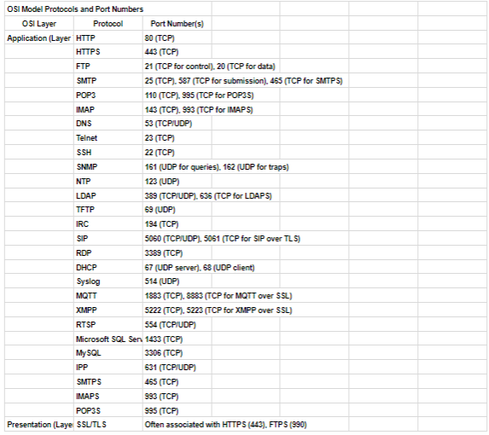

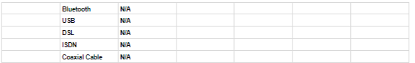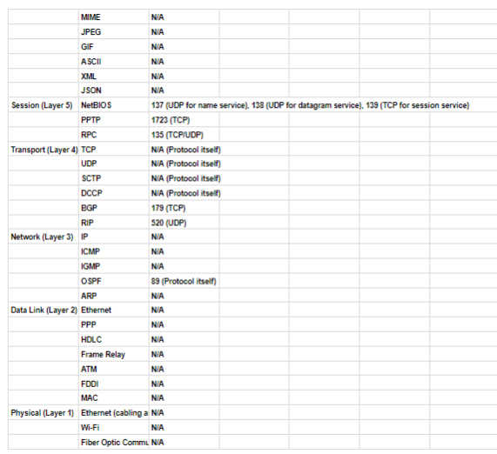

**Task 3: Lab**

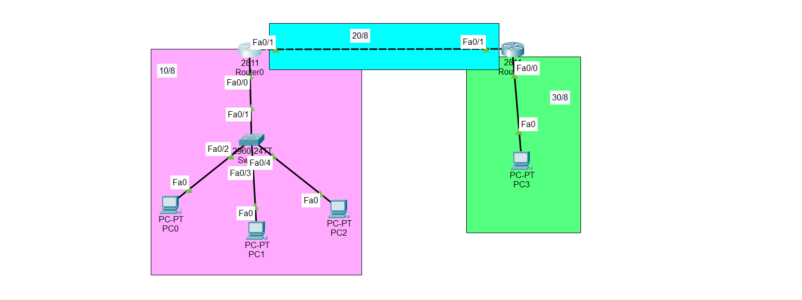

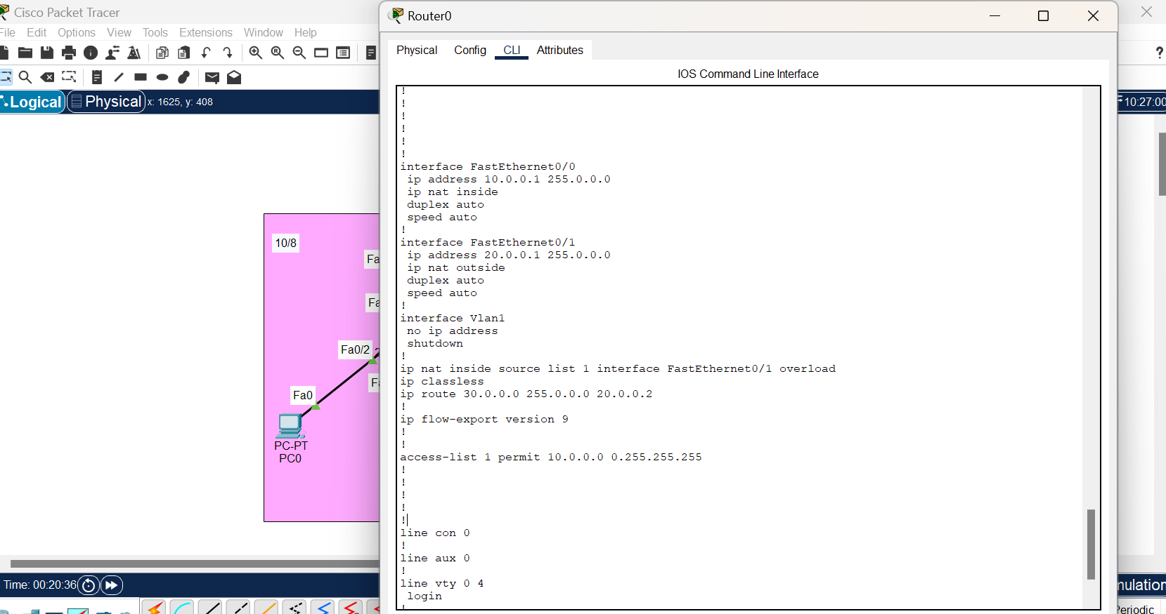

Commands we need to do

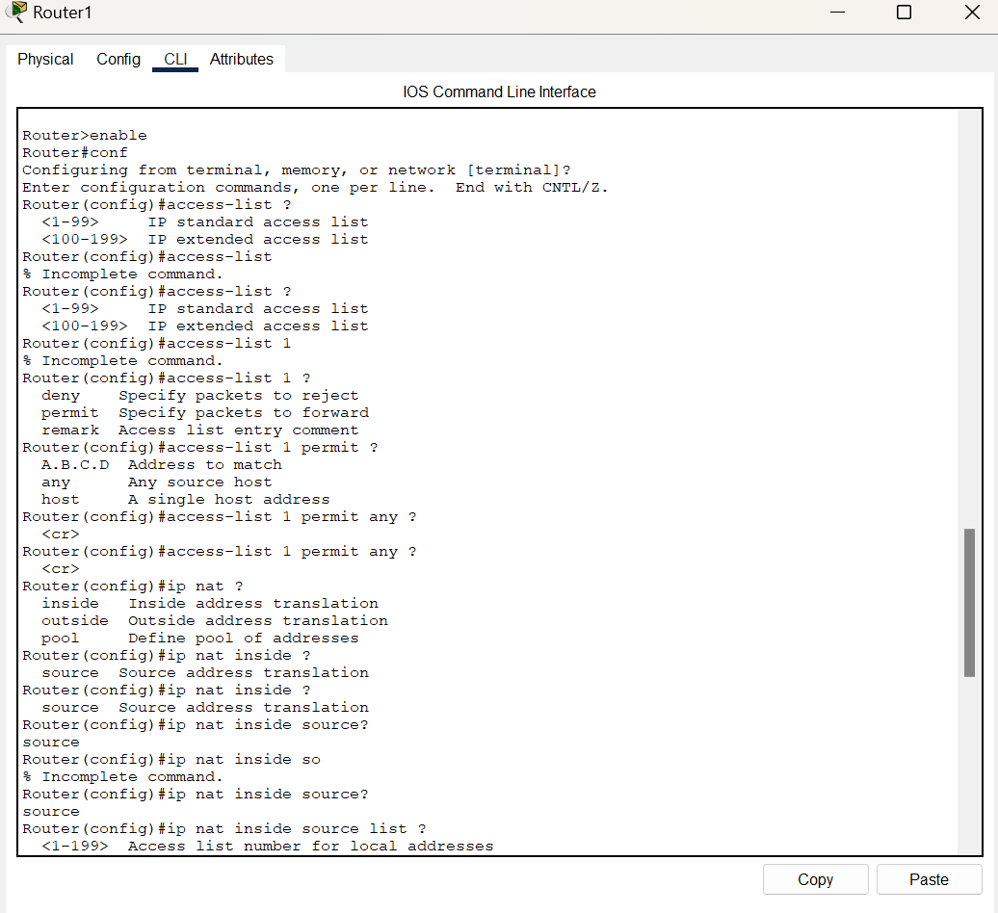

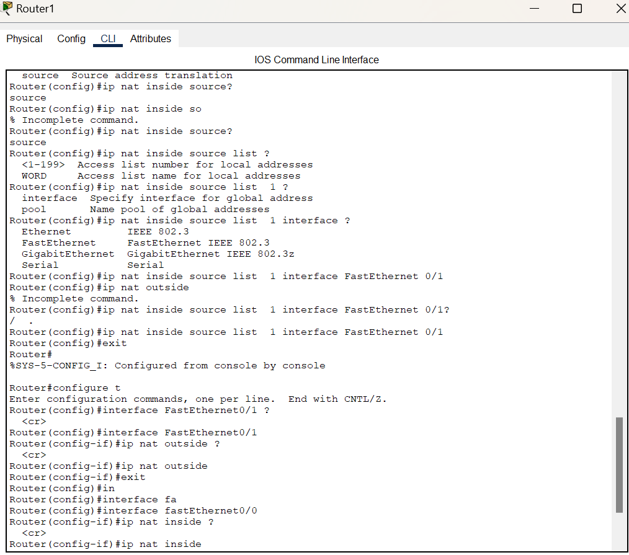

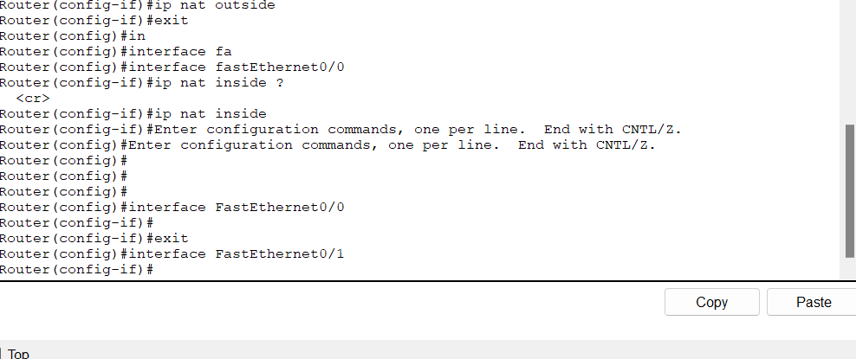extra command the command is end at the ip nat inside is enough.

